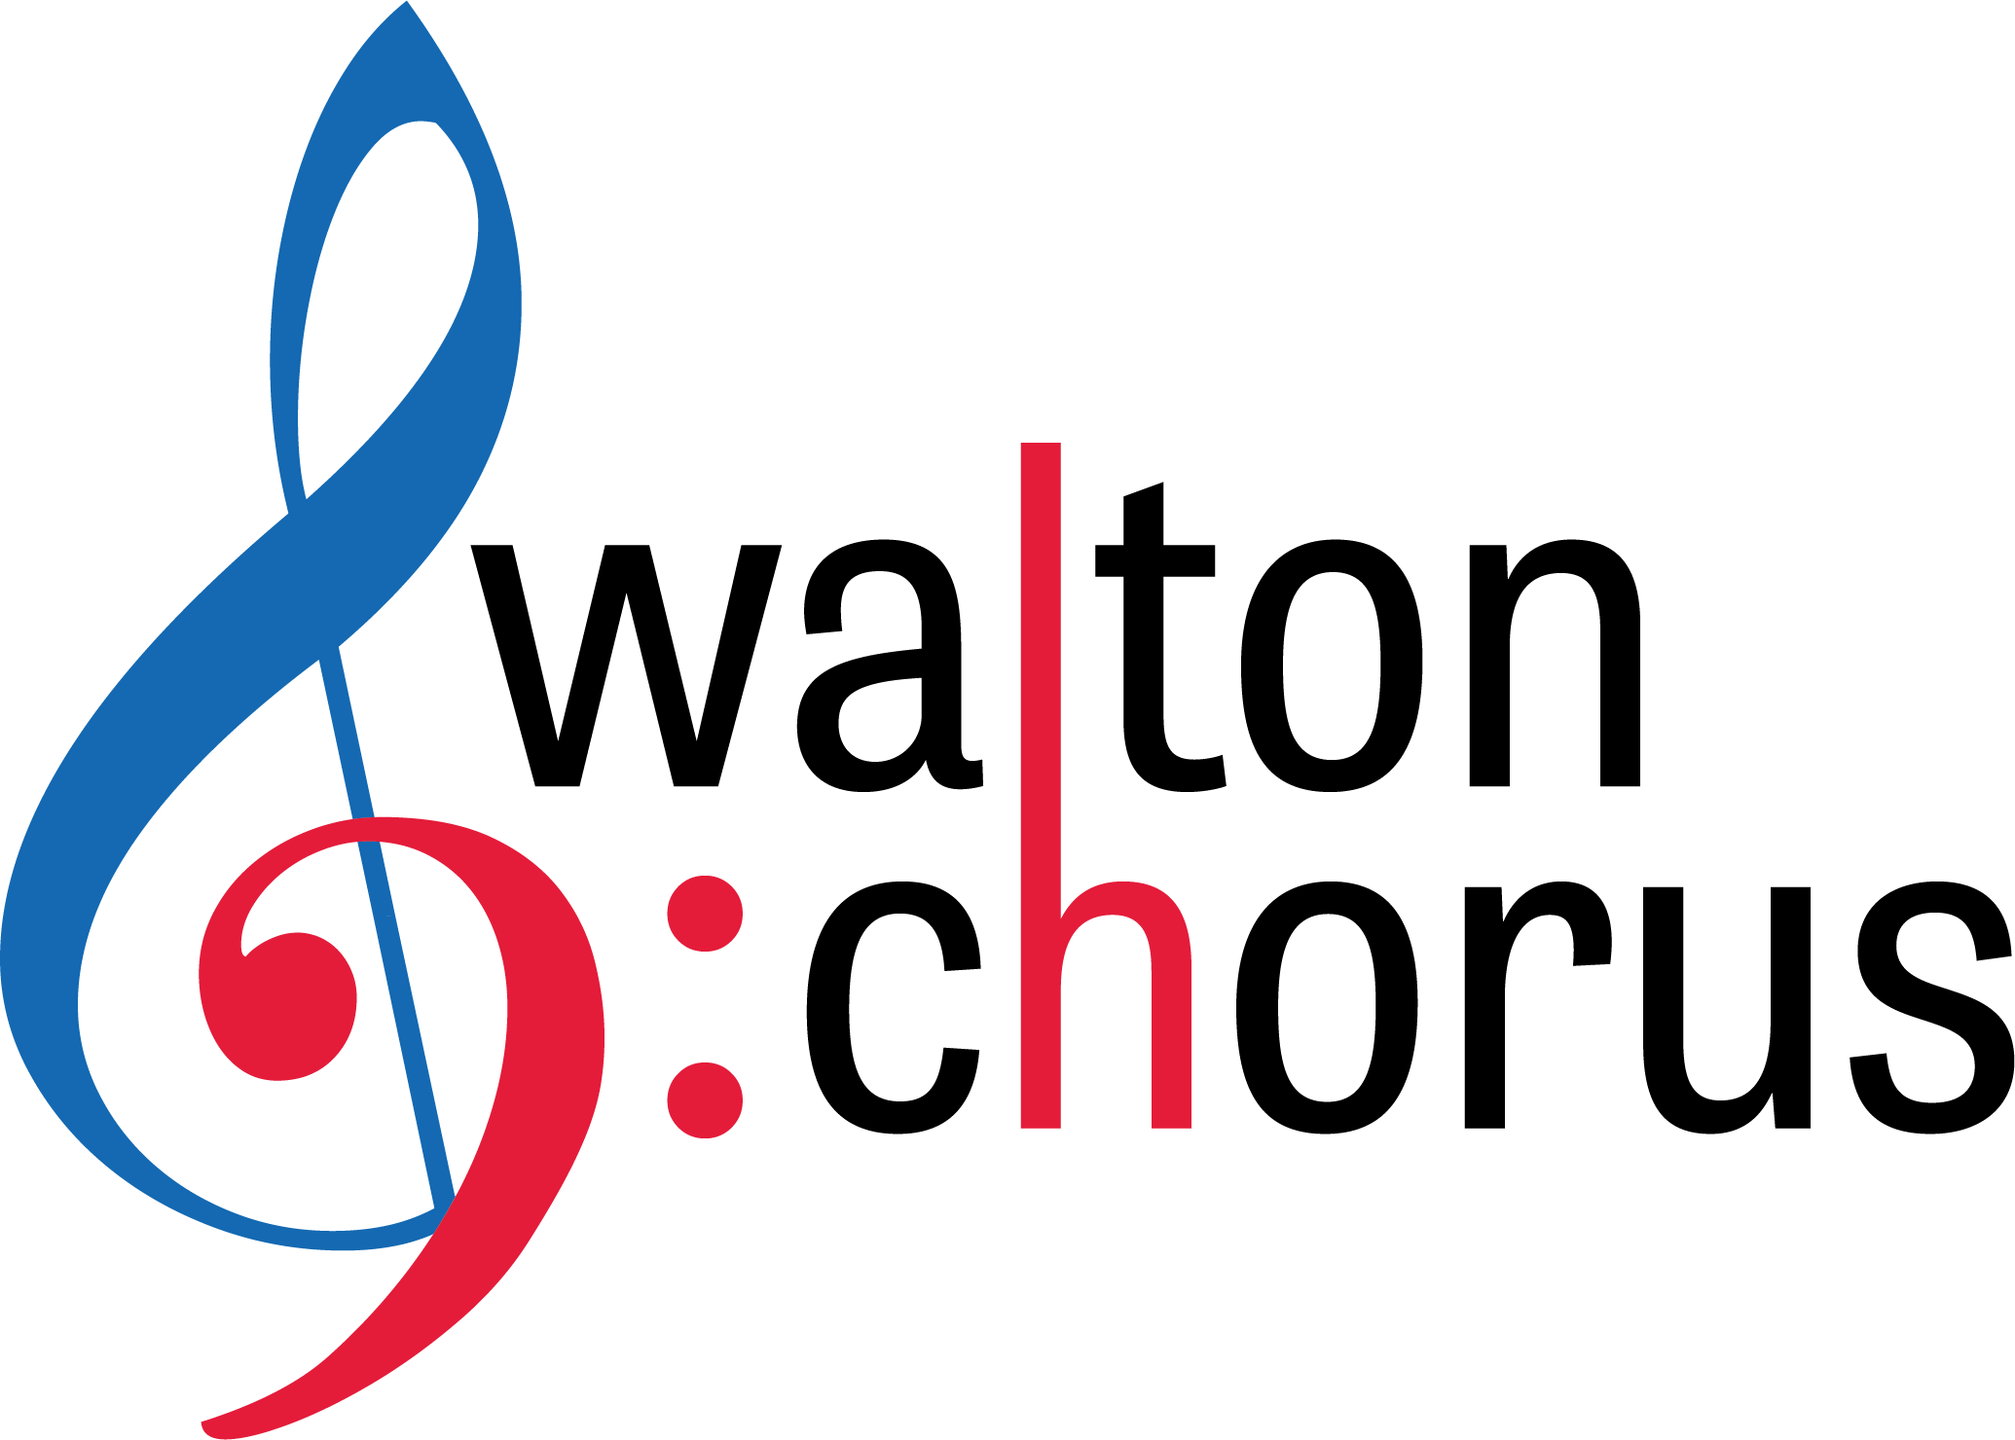
Walton High School Choral Department

Dr. Jana Williams, Director
Mrs. Maggie Allyn, Assistant Director
1590 Bill Murdock Road
Marietta, GA 30062
Phone: 770.578.3225 x 051
Fax: 770.578.3227
E-mail: dwwaltonchorus@gmail.com
maggiewaltonchorus@gmail.com
WALTON CHORUS DIGITAL LEARNING SYLLABUS
Beginning March 16th, all chorus students should spend 20-minutes per school day rehearsing your part in spring concert music and logging your practice time on the provided practice log. Students should then spend 10-minutes listening and watching choral music (see list of suggestions below) and complete a 2-sentence reflection. Each class has a password-protected folder that can be accessed by going to tinyurl.com/ChorusDigitalLearning. In each folder, you will find find PDF’s of your music and rehearsal tracks for each part. Your practice log and reflection form must be submitted via e-mail by 4:00 PM on Friday’s. We will have daily Teacher Virtual Office Hours from 1:00-1:30 PM each day, which means we will be available via e-mail.
Members of A Cappella, Camerata Singers and boys of Raider Singers should e-mail the form to dwwaltonchorus@gmail.com.
Members of Bel Canto, Select Women’s Ensemble and the girls of Raider Singers should e-mail the form to maggiewaltonchorus@gmail.com.
Assuming we’re still out of school, on Tuesday, March 31st your assignment is to record yourself singing your part of each spring concert piece and uploading it to CHARMS (see document entitled “CHARMS Blue Assignment”).
Choirs to watch/listen for reflections:
Trinity College Choir Cambridge
Atlanta Master Chorale
VOCES8
Tenebrae Choir
St. Olaf College
Westminster College Choir
Eric Whitacre conducting virtual choirs/festivals, etc.

