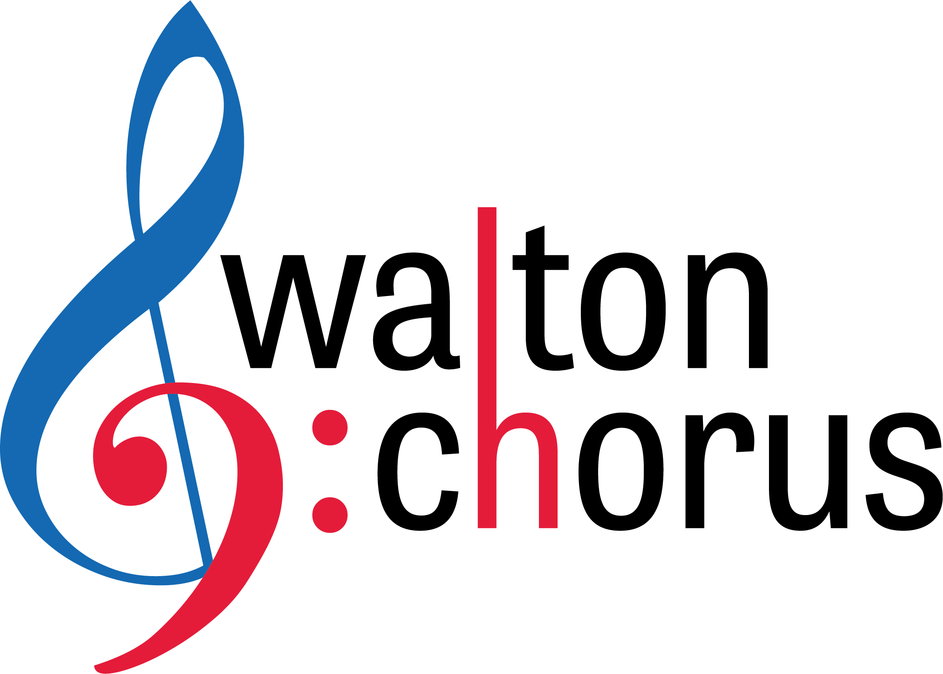
Walton High School Choral Department

Dr. Jana Williams, Director
Mrs. Maggie Allyn, Assistant Director
1590 Bill Murdock Road
Marietta, GA 30062
Phone: 770.578.3225 x 051
Fax: 770.578.3227
E-mail: dwwaltonchorus@gmail.com
maggiewaltonchorus@gmail.com
GROWING AS A MUSICIAN DURING THIS CHOIRUNTINE*
Due each Friday by 4pm

Greetings, singers! For this assignment, please pick ONE thing to do and submit by Friday at 4 pm. We will continue to use this list going forward, so just pick your favorite for this week. This is your opportunity to direct your own learning and interests. There is no way for us to replicate the beauty and benefits of singing together in real-time at this point, but we can do things to continue to thrive as musicians. Realizing that you all have different prior experiences and different ability levels, we have provided learning experiences that allow you to:
- Create
- Analyze
- Perform
- Explore
- Process
- Practice
- Learn from others
- Learn by yourself
Each Friday by 4 pm, email either dwwaltonchorus@gmail.com or maggiewaltonchorus@gmail.com (A Cappella, Camerata Singers and Raider Singer guys to Dr. Williams; Bel Canto, Raider Singer Girls and Select Women’s Ensemble to Mrs. Allyn) with answers to the following questions:
- What did you do?
- What did you learn from doing it?
- What could you do next to extend this experience?
Here are your CHOICES (PICK ONE):
Be a composer who uses music technology: Make a piece of music using garageband. Include a vocal line and at least three other sound layers. Tell me about your composition process either by writing up a short summary or recording an audio response that is between two and five minutes long. Your garageband piece should be at least 30 seconds long. And answer the three questions.
Be a choral composer who uses traditional notation: Make a piece of music using MuseScore (free online). Compose either a warm-up exercise (complete with lyrics) or a piece for choir (SATB with or without other instrumentation). Tell us about your composition process either by writing up a short summary or recording an audio response that is between two and five minutes long. Your piece length is determined by you. And answer the three questions.
Be a performer: Record audio or video of yourself performing your favorite song to a karaoke track. Tell us why it’s your favorite song right now and why you like singing it. And answer the three questions.
Be a performer/creator: Record an audio or video of yourself performing your own harmony parts that you have made up to a recording of your favorite song. Imagine you are a back-up singer and be creative! Tell us why it’s your favorite song right now and why you like it. And answer the three questions.
Be a teacher: Find a video online that would be valuable for your peers to watch that is related to singing/choir/music. Write up an explanation of why it would be beneficial for anyone in our class and what you learned from watching it. Provide some prompt questions that could help students think about the content in the video. And answer the three questions.
Conduct an interview: Ask a family member you’re stuck with (or call someone) about their music making. Some possible questions are: Did they/do they have formal or informal music education? How do they prefer making music? What impact has music had on them? Do they think that all students should be exposed to music education? What memories do they have about music making? Write up a summary of your findings with any insights you have about this interaction or record an audio response that is between two and five minutes long. And answer the three questions.
Create a playlist: Assemble a playlist of at least ten pieces on your favorite music listening app or provide a list with links. Pick a theme for your playlist. For each piece, provide a short and specific description of what you like about that piece. Your playlist can include any medium of music (choral, vocal, instrumental, any genre). And answer the three questions.
Do a comparative analysis: Find two recordings of the same piece by two different artists (you could use one of our choral pieces we are preparing or a song recorded by two different artists). Analyze how they are similar and how they are different and why you prefer one over the other. Write up an analysis (at least two hundred words). And answer the three questions.
Explore music careers: Consider all of the ways that you consume music now that you are social distancing. Explore and pick a music career that is responsible for bringing music into your home (e.g. sound engineer, commercial artist, film composer, jingle writer, youtube artist). Write up a short summary of what this person does, what type of schooling would be helpful for this career, skills necessary for this job, and your thoughts on that profession. And answer the three questions.
Listen to Song Exploder: Pick your favorite artist or explore someone new. Listen and respond to one of these Song Exploder episodes. http://songexploder.net/episodes What is their creation process like? What surprises you about this episode? Write up a summary of your findings with any insights you have about this or record an audio response that is between two and five minutes long. And answer the three questions.
Keep a listening log: Pick three pieces of music and journal about them. Include your thoughts about personal connection to the pieces, as well as insights into how the pieces are constructed. Maybe consider how the pieces are similar or different to each other. Either provide your journal entries or record an audio response that is between two and five minutes long. And answer the three questions.
Make a presentation: Using a slide presentation, share with me your favorite piece of music. Format your slides like this: slide #1 title and artist, slide #2 an analysis of the piece from a construction standpoint, slide #3 why we should listen to this piece, slide #4 a link to a recording. And answer the three questions.
Pitch an idea: If you would like to create your own music learning experience, pitch your idea here. I will review your suggestion and give you the go-ahead or offer suggestions for making it viable. Be sure to make your case for why you would benefit from your own idea. You will receive credit for the assignment (not the pitch- so pitch early). And answer the three questions at the conclusion of your work.
Practice music theory skills: Pick three lessons from http://www.musictheory.net and complete the corresponding exercises. Screenshot your score, once you get over an 80% passing rate for each of the three exercises. Be prepared to answer a few theory questions I direct at you related to your exercises (don’t have someone else do these for you, actually practice them yourself). And answer the three questions.
Propose a choral program: Create a choral program of your own. Decide how to structure your program and pick pieces that fit your vision. Explore music publishing or distribution websites for ideas. Include at least five choral pieces. Create a slideshow with a slide for each piece that explains why you have chosen that piece and a link to a recording of it. Have one additional slide that explains your vision. And answer the three questions.
Research: Pick one of our pieces we are preparing and do some research on it. Things to consider might be intent of the composer, context of time and place, lyric interpretations, and/or structure of the composition. Write up a detailed description of the piece that demonstrates your understanding of it from a deeper perspective. And answer the three questions.
Watch a Tiny Desk Concert: Pick your favorite artist or explore someone new. Watch and respond to one of these Tiny Desk Concerts. How is their performance here different from their previously recorded versions? Does the format of the Tiny Desk Concert help or hinder their music making? https://www.npr.org/series/tiny-desk-concerts/ Write up a summary of your findings with any insights you have about this or record an audio response that is between two and five minutes long. And answer the three questions.
Learn to play an instrument. Is there a ukulele, guitar or keyboard in your house? Now’s the time to learn to play. Find a youtube video, and get started. Keep a log of your practice time each day. And answer the three questions.
The intent of these experiences is for you to grow as a musician. Email us with any questions you have. We are happy to help support your learning. Be well, stay home, and keep music in your life!

*Zaim’s idea – thank you, Zaim

